1. (25p) Answer all the questions in an electronic document. By using the MATLAB routine developed in 5.3 of session 5 (RCS): For the following distribution. Obtain the equivalent RCS in polar coordinates as a function of φ, in the range from 0 to 2π. Assume σ0=1 m2

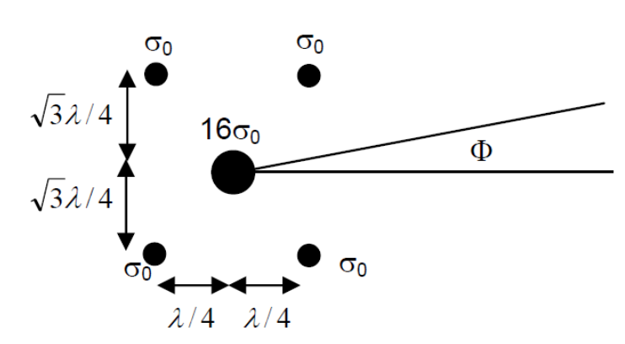

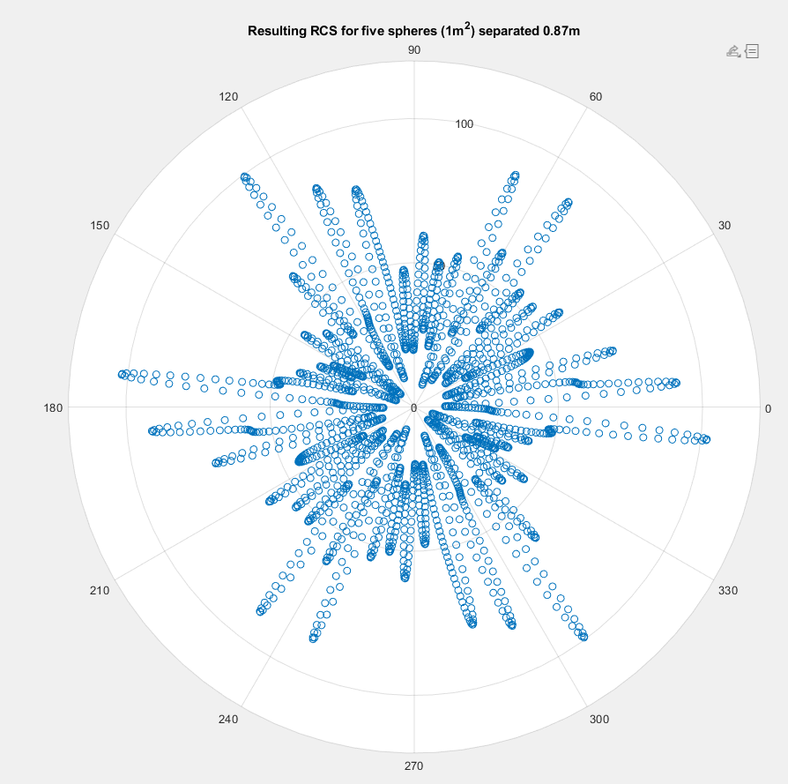

Out of 5, 4 are 1m^2 and 1 is 16\*1m^2